**Assignment week 2**

**Creating table in my sql**

CREATE TABLE employees (

id INT PRIMARY KEY,

name VARCHAR(100),

age INT,

department VARCHAR(100)

);

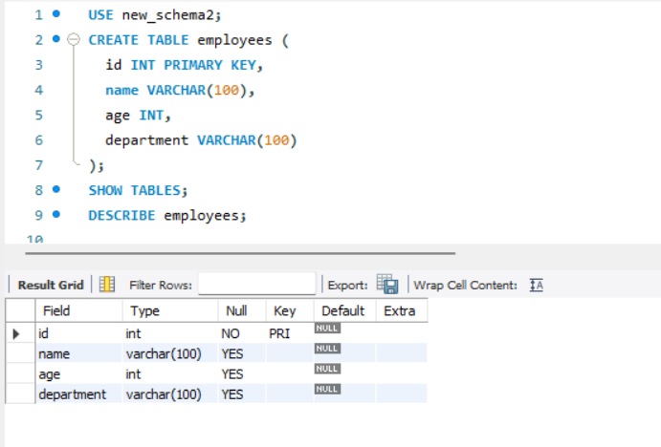

**Updating a table:**

ALTER TABLE employees ADD COLUMN salary DECIMAL(10, 2);

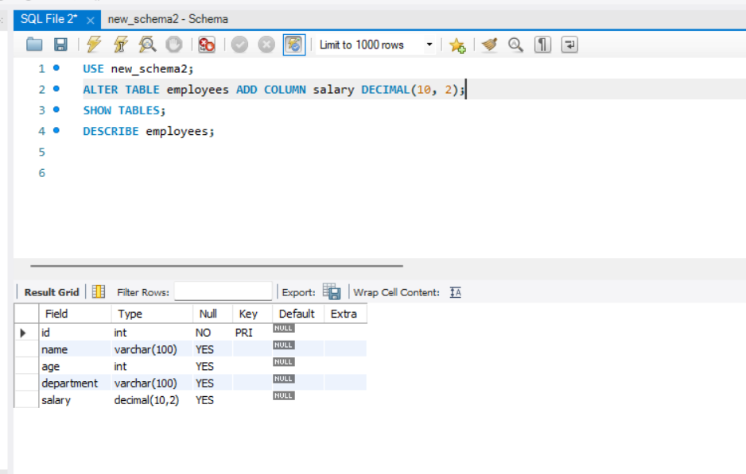

**Joining in MySql:**

SELECT employees.name, employees.age, departments.department_name

FROM employees

JOIN departments ON employees.department_id = departments.id;

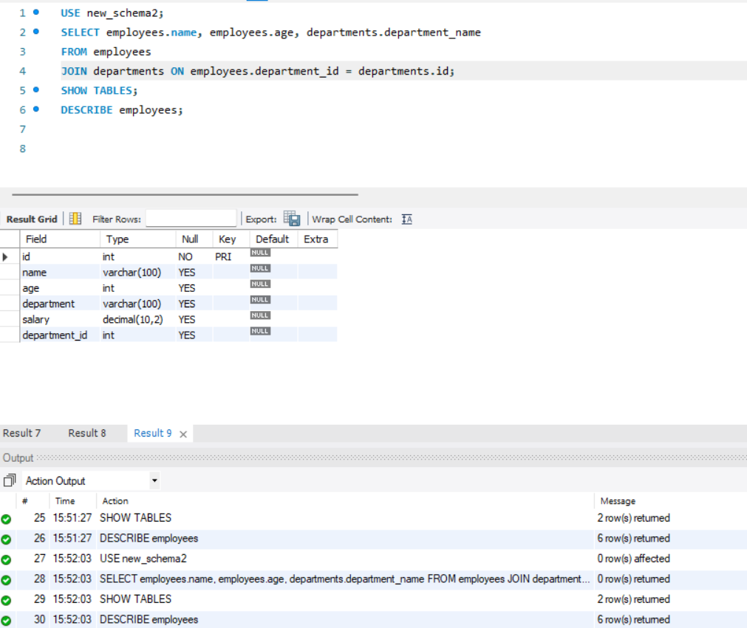

**Deleting table in Mysql:**

DROP TABLE employees;

**Creating a document in MongoDB:**

db.employees.insertOne({

id: 1,

name: "John Doe",

age: 30,

department: "Sales"

});

**Updating a document:**

db.employees.updateOne(

{ id: 1 },

{ $set: { department: "Marketing" } }

);

**Deleting a document:**

db.employees.deleteOne({ id: 1 });